Application To Be A Member of the Village of Rycroft Library Board

Library Bylaw

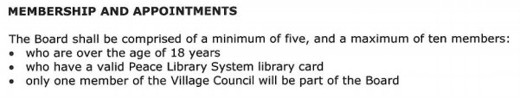

I would like to be considered for a position on the Village of Rycroft Library Board

Name:……………………………………………………………………………………………..

Address:………………………………………………………………………………………….

……………………………………………………………………………………………………….. Phone:…………………………………………………………………..
Email:………………………………………………………………………………………………

Signed:…………………………………………………………………………………………….

Date:……………………………………………………………

Drop completed application off at the Rycroft Municipal Library

(Write on the back if you wish to add anything to your application.)

Revised 13 Oct 2021

